# C# Web Basics Retake Exam – 23 December 2020

# Car Shop



Exam problems for the [C# Web Basics course @ SoftUni](https://softuni.bg/courses/csharp-web-basics). Submit your solutions in the **SoftUni judge** system (delete all "**bin**"/"**obj**" folders).

**SoftUni Car shop** is the newest and hottest place to tune up your car or fix any outstanding issues.

## Technological Requirements

* Use the **SUS**
* Use **Entity Framework Core – 3.1**

The Technological Requirements are **ABSOLUTE**. If you do not follow them, you will **NOT** be scored for other Requirements.

Now that you know the **Technological Requirements**, let us see what the **Functional Requirements** are.

## Database Requirements

The **Database** of **SoftUni Car shop** needs to support **3 entities**:

### User

* Has an Id – a **string, Primary Key**
* Has a Username – a string with **min length** **4** and **max length 20** (**required**)
* Has an Email - a string (**required**)
* Has a Password – a string with **min length** **5** and **max length 20** - hashed in the database (**required**)
* Has а **IsMechanic** – a **bool** indicating if the user is a mechanic or a client

### Car

* Has an Id – a **string, Primary Key**
* Has a Model – a string with **min length** **5** and **max length 20** (**required**)
* Has a Year – a **number** (**required**)
* Has a PictureUrl – **string** (**required**)
* Has a PlateNumber – a **string –** Must be a valid Plate number (2 Capital English letters, followed by 4 digits, followed by 2 Capital English letters **(required)**
* Has a **OwnerId** – a **string** (**required**)
* Has a Owner – a User object
* Has **Issues** collection – an **Issue** type

### Issue

* Has an **Id** – a **string**, **Primary Key**
* Has a **Description** – a string with **min length** **5** (**required**)
* Has a **IsFixed – a bool** indicating if the issue has been fixed or not (**required**)
* Has a **CarId** – a **string** (**required**)
* Has Car – a Car object

Implement the entities with the **correct datatypes** and their **relations**.

## Page Requirements

### Index Page (logged-out user)

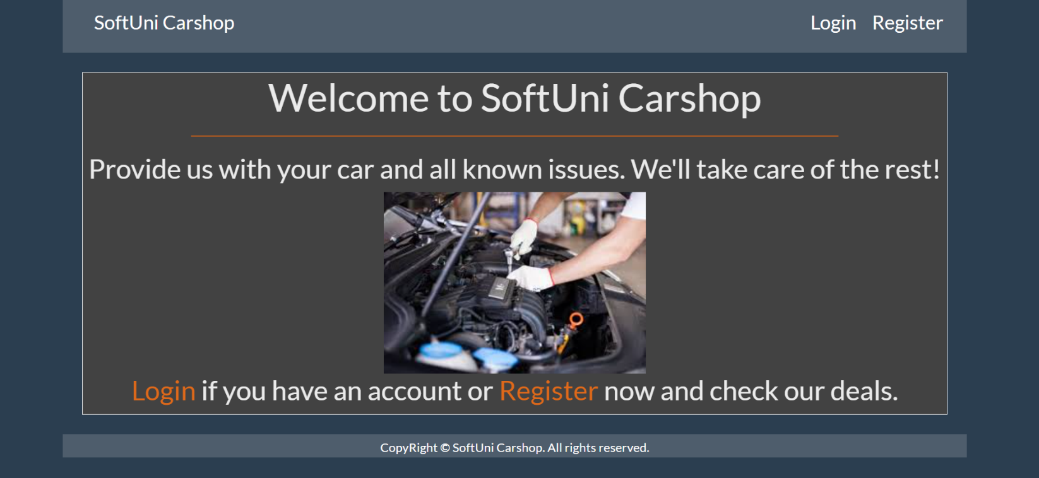

### Login Page (logged-out user)

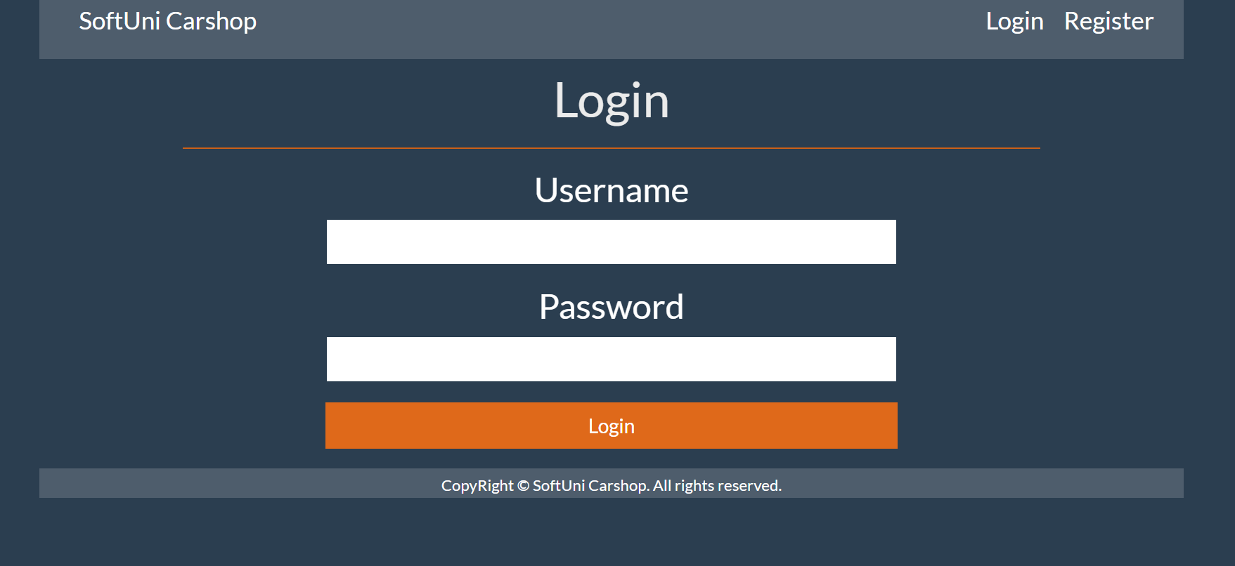

### Register Page (logged-out user)

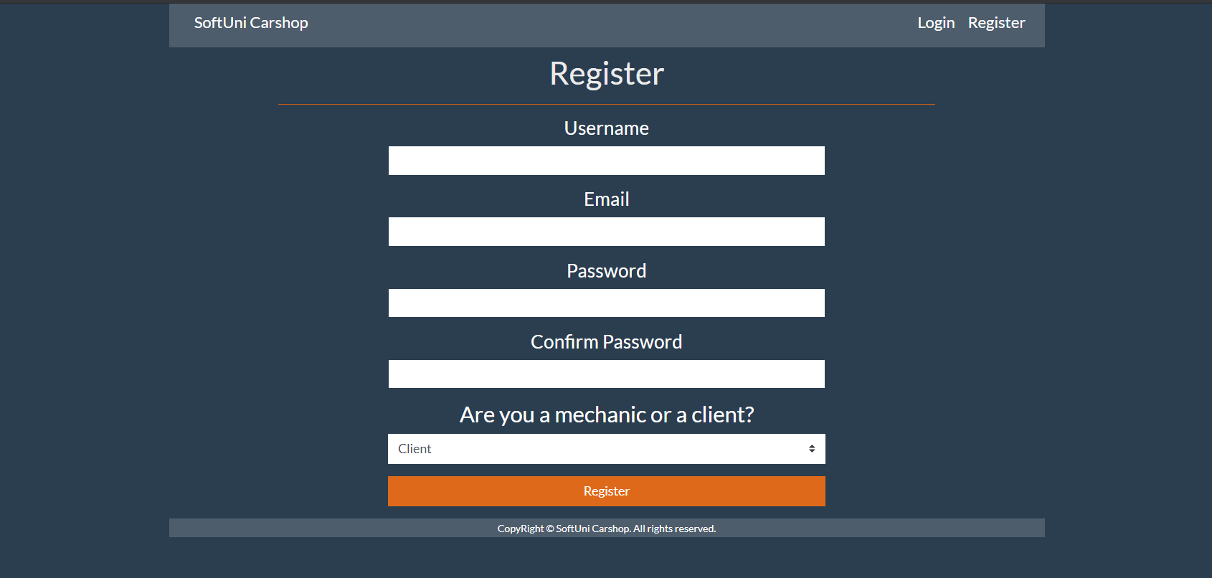

### /Cars/All (logged-in user)

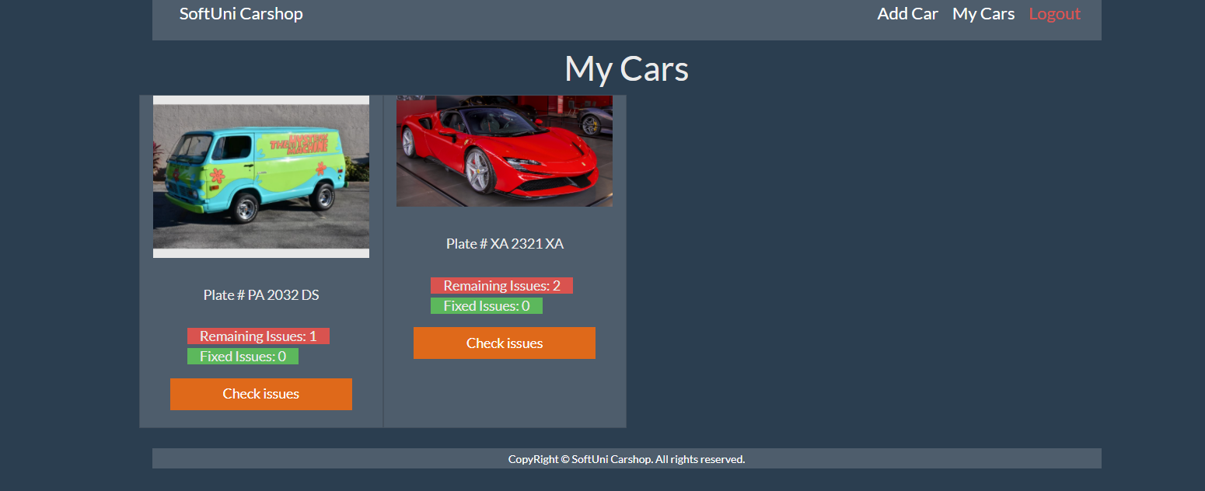

**NOTE**: If the user is logged in and he tries to go the home page, the application must redirect him to the **/Cars/All**

### /Cars/Add (logged-in user that is a client)

### /Issues/CarIssues?CarId={id} (logged-in user)

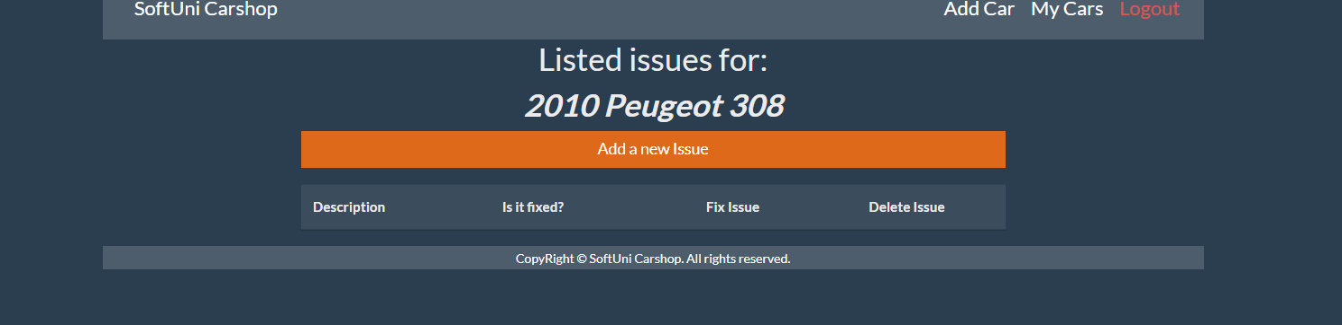

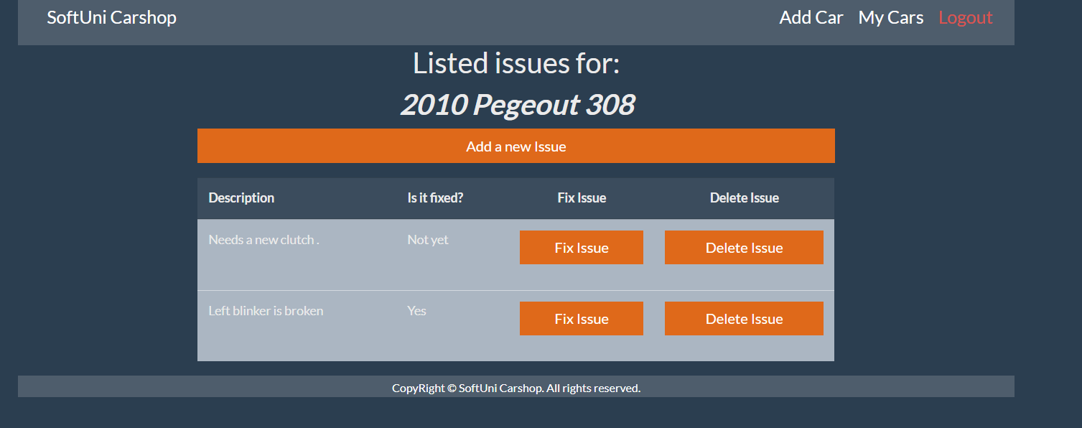

### /Issues/Add?CarId={id} (logged-in user)

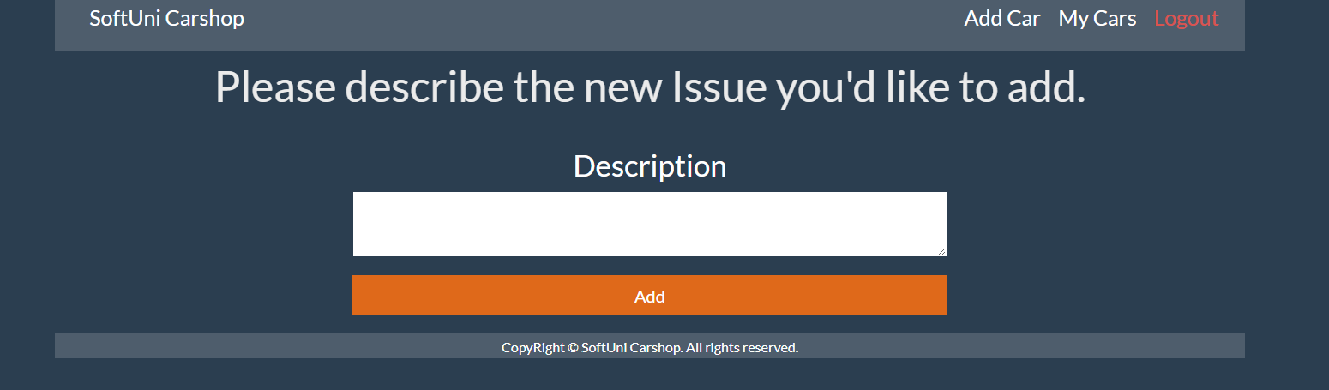

/Issues/Delete?issueId={Id}&CarId={Id} The Delete button deletes the respective issue. Both the owner of the car and a mechanic can delete an issue.

/Issues/Fix?issueId={Id}&CarId={Id} The Fix Issue button changes the value in the ***Is it fixed?*** Column to ***Yes.*** Only users that are mechanics can fix issues.

If pressing a button is successful, reload the page.

**NOTE**: The templates should look **EXACTLY** as shown above.

**NOTE**: The templates do **NOT** **require** **additional** **CSS** for you to write. Only **bootstrap** and the **given css** are enough.

## Functionality

The functionality of **Car shop** platform is very simple.

### Users

Guests can see Register, Login and Home views.

There are two kinds of Users for this app:

* **Clients** (isMechanic=false)can add new cars. Clients can see all the cars they have added but not the cars of other clients on the Cars/All page. For every car, they have added they can also view the list of issues and they can add or delete issues. **They cannot fix issues.**
* **Mechanics** (isMechanic=true) **cannot add new cars.** On the Cars/All page, they can **view all cars that have unfixed issues**. For every car, theycan also view the list of issues, add and delete issues.Unlike clients **– mechanics can fix an issue** (set isFixed to true).

### Cars

**Clients can add cars**. All cars that the currently logged in user has access to are visualized on the **all cars page**, each one in its own bootstrap card (as shown in the /Cars/All snapshot above).

Each car has **Image, model and year** (on hover), **Plate number**, count of **Fixed Issues** and count of **unfixed (Remaining) issues** and a **Check issues** button.

**Cars** are visualized on the **My Cars page** with a button – [**Check issues**].

* The [**Check issues**] button leads to the **list of issues (/Issues/CarIssues?CarId={Id}** page for the particular car.

### **Issues**

**Users can add issues on all cars they have access to**. All **issues for a particular car** are visualized in a table on the **car issues page**.

There is a button on top of the issues table– [**Add a new Issue**].

* The [**Add a new Issue**] button leads to the **add issue view (/Issues/Add?CarId= {Id})**.

There are two other buttons [**Fix Issue**] and [**Delete Issue**]

* The [**Fix Issue**] sets the isFixed property of the respective issue to true and reloads the page.
* The [**Delete Issue**] button deletes the respective issue from the database and reloads the page.

### Redirections

* Upon successful **registration** of a **User**, redirect to the **Login** **Page**.
* Upon successful **login** of a **User**, redirect to the /**Cars/All**.
* Upon successful **creation** of **a** **Car**, redirect to the /**Cars/All**.
* Upon successfully **adding an issue to a car**, redirect to the /**Issues/CarIssues?carId={Id}** (reload the page)
* Upon successful **deletion** of **an issue**, redirect to the /**Issues/CarIssues?carId={Id}** (reload the page)
* If any of the validations in the POST forms do not pass, show the built-in SUS Error with an appropriate message.

## Security

The Security section mainly describes access requirements. Configurations about which users can access specific functionalities and pages:

* Guest (not logged in) users **can** access Index page.
* Guest (not logged in) users **can** access Login page.
* Guest (not logged in) users **can** access Register page.
* Users (logged in) **cannot** access Guest pages.
* Users (logged in) **can** access Cars/All page and functionality.
* Users (logged in – **clients**) **can** access Cars/Add page.
* Users (logged in – **mechanics**) **cannot** access Cars/Add page.
* Users (logged in) **can** access Issues/CarIssues to add or delete an Issue.
* Users (logged in – **mechanics**) **can** use the Fix Issue functionality.
* Users (logged in - **clients**) **cannot** use the Fix Issue functionality.
* Users (logged in) **can** access Logout functionality.

## Code Quality

Make sure you provide the best architecture possible. Structure your code into different classes; follow the principles of high-quality code (**SOLID**). You will be scored for the Code Quality and Architecture of your project.

## Scoring

### Database Requirements – 10 points.

### Template Requirements – 10 points.

### Functionality – 50 points.

### Security – 10 points.

### Code Quality – 15 points.

### Data Validation – 5 points.